School Context as at 20th June 2025

School Roll | School Attendance | Percentage ASN | PEF Allocation
390 | 92.16% | ASN  28% | £196,000
SIMD Profile

Cycle of Improvement
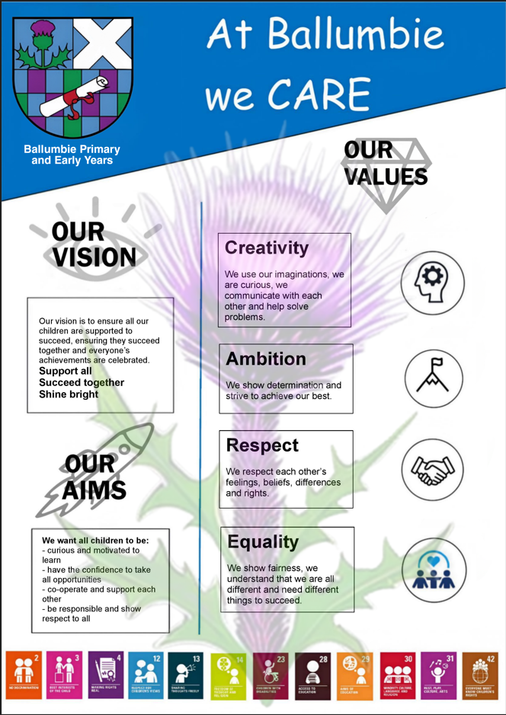

School Priorities 2025/26


SIP Priority 1
Specific area for improvement |  |  | Raise attainment in literacy to 80% by June 2025 (Progress)
Rationale for Improvement  (based on evidence from key stakeholders) |  |  | Progress and Achievement data shows that writing progress impacts our literacy attainment
Equity Gap (if relevant)

NIF PRIORITIES  Improvement in attainment, particularly in literacy and numeracy  Closing the attainment gap between the most and least disadvantaged children and young people  Improvement in attainment, particularly in literacy and numeracy  Choose an item.  Choose an item. | NIF DRIVERS  Assessment of Children's Progress  Teacher Professionalism  Performance Information  School Leadership  Choose an item.  Choose an item. |  |  | EDLM PRIORITY    Progress |  | PEF (where applicable)  Intervention for equity & cost  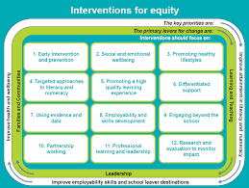  5. Promoting a high quality learning experience  11. Professional learning and leadership  6. Differentiated support |  | HGIOS QI  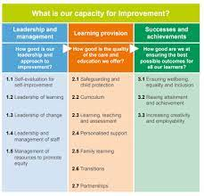  2.3 Learning, Teaching and Assessment  3.2 Raising attainment and achievement
Intended Outcome (impact) |  | Actions required to reach desired outcome |  |  | Measurement & Evidence |  | Who |  | When | Resources
Raise attainment in literacy to 80% by June 2026 |  | All teaching staff to implement CYPIC Writing CLPL with Education Scotland and Pedagogy team – across P1 – P7  - Gathering of literacy data  - Set Learning Intention and Success Criteria based on data  - Stretch Aims are focused on needs of children  - Assessment a key element of planning to inform next steps  - Raising Attainment strategy linked to writing  Quality Assurance discussions focused on raising attainment in all areas of literacy and numeracy  Working group (Karen, David, Lindsay, Nicki) – Develop a year plan of writing progression across P1- P7 for session 26/27  Development of an online writing resource bank  Development of writing assessment across P1 – P7  Moderation – continue with model of moderation activity in line with benchmarks – focus on all areas of literacy  Tracking of achievement of a level data and progress through a level to be managed through a new tracking tool, all staff to be trained and make use of new tracking tool.  Attain Reading School Bronze level award:  - Develop action plan with Parent Council and pupil group  - Reading/Parent Council organise literacy events – reading café, reading displays, book reviews, |  |  | Extended Review evidence(2023)/  PSV evidence 2024/25: Learning and Teaching – Satisfactory – Very good  Progress and Achievement data-  Tracking of Pupil Progress is consistent through moderation and QA processes – a focus on literacy – staff to discuss assessment data and next steps in learning as part of raising attainment strategy and quality assurance processes. See profile data.  Measurement method:  PSV – QI 2.3 data  Attainment data – Progress and Achievement data  Stretch aims:  QI 2.3 – Good  Stretch aims 2026:  Reading 85%  Writing 79.5%  L&T 89%  Literacy 80% |  | KB/  PC  and all teaching staff |  | November 2025 – May 2026
   | 2024 | 2025
  Writing P1 | 77% | 75%
  Writing P4 | 73% | 76%
  Writing P7 | 68% | 69%
  Overall attainment | 73% | 73%
   | 2024 | 2025
  L&T P1 | 84% | 80%
  L&T P4 | 93% | 82%
  L&T P7 | 77% | 84%
  Overall attainment | 85% | 82%
   | 2024 | 2025
  Reading P1 | 80% | 72%
  Reading P4 | 82% | 81%
  Reading P7 | 74% | 83%
  Overall attainment | 79% | 79%
Progress
November 2025
Staff team have reviewed PandA data to discuss with colleagues across the city at the planned CYPIC training
All teachers working with Pedagogy team and have begun CYPIC writing pedagogy with classes.

All teachers trained in use of new tracking tool, to track progress through a level and achievement of a level.
Raising attainment discussions planned and teachers have completed format for discussion at meetings.

Action plan for Reading School award has been drafted for discussion with class teacher lead, Parent Council and Pupil group.

SIP Priority 2
Specific area for improvement |  |  | Develop our school as an inclusive school where all children feel valued, respected, and can participate fully in their education (Participation and Presence)
Rationale for Improvement
(based on evidence from key stakeholders)
Equity Gap (if relevant)

NIF PRIORITIES  Placing the human rights and needs of every child and young person at the centre of education  Improvement in children and young people's health and wellbeing  Improvement in attainment, particularly in literacy and numeracy  Choose an item.  Choose an item. | NIF DRIVERS  School Leadership  School Improvement  Choose an item.  Choose an item.  Choose an item.  Choose an item. |  |  | EDLM PRIORITY  Participation |  | PEF (where applicable)  Intervention for equity & cost  2. Social and Emotional Wellbeing  5. Promoting a high quality learning experience  Choose an item. |  | HGIOS QI  1.3 Leadership of change  3.1 Enquring wellbeing, equality and inclusion
Intended Outcome (impact) |  | Actions required to reach desired outcome |  |  | Measurement & Evidence |  | Who |  | When | Resources
All stakeholders feel welcomed, valued and respected (listened to)  All children participate fully in their education |  | Develop an inclusive environment and ethos  Agree as a staff team what inclusion means and looks like at Ballumbie  Audit our learning environments in line with the Dundee Standard of Inclusive Practice or The Circle Inclusive Classroom Scale to determine next steps  Ensure visuals are in use and consistent across all environments  All classrooms to develop a self-regulation area – to be consistent across all rooms to include wellbeing wall and ‘talk to teacher’ box  Ensure all children have at least one trusted adult in school – use of Glasgow Wellbeing data and questionnaire – work with Pupil Council to review  Active Schools Assistant to work with small groups and individuals to develop self-regulation and promote engagement and school attendance.  Learning, Teaching and Assessment  Practical differentiation CLPL and agree standard for Ballumbie (OSIRIS)  Develop a whole school Universal Supports plan  As part of our Ballumbie Learning and Teaching Standard – encompass Universal supports  Review planning for individuals and small groups to ensure a consistent approach  Rights Respecting School/ School values  All staff to familiarise themselves with Relationships policy and implement key areas in classrooms (INSET 1)  All staff revisit trauma and nurture principles (INSET 1)  UNCRC display in reception area and across the school  Pupil friendly behaviour pathway devised, shared and implemented by all and visible in all classrooms  Create a knowledge and understanding of children’s rights through assemblies and Rights Respecting Group  Right of the Month is embedded into class learning linked to our school values  Embed our new school values into practice through discussions, assemblies, etc |  |  | Survey evidence shows that 86% of families feel comfortable approaching the school.  36% of families felt their views were taken into account when making change.  Glasgow Wellbeing data shows that some children do not feel affiliation to the school and scores show lower levels in healthy and safe.  A few children showing distressed and disengaged behaviours across the school. This has decreased, however, is still visible.  Measure of progress:  Survey data – children feel safe (Glasgow Wellbeing tool)  Survey data – children and families feel welcome, valued and respected (Forms)  Attendance, VI and Exclusion data  Silver UNCRC award gained  Audit of learning environments – pre and post (Circle tool or Dundee Standard)  Active school engagement records for clubs etc. Individuals school attendance/ attainment/ participation in learning |  | CP  Beehive/  Sunshine rooms staff team  KB/  H&WB group |  | Term 1 – Term 3 | Circle tool  OSIRIS  Pedagogy Team CLPL padlet and resources  Glasgow Wellbeing tool  UNCRC  AIS/DEPS  Active Schools recourses  H&WB group
Progress
Standard of Inclusive Practice shared with all staff. Staff reviewed children with ABLe plans against the Standard to ensure universal supports are in place.
PT SfL trained and supported by DEPS to create new IEPS and ASPs. Acting DHT working with Inclusion Support Team to ensure CSP processes are updated adhered to.
Stepped approach to support improvements in our targeted learning zones and upskill staff team with AIS and S&LT. Focus on communication.
H&WB group set up focusing on children’s Glasgow Wellbeing scores – focus on Safe in School and playground ethos. Pupil Council also focusing on respect.
Active Schools Assistant working with small groups and individuals to develop self-regulation and promote engagement and school attendance – focus on P5 stage and targeted support groups.
Targeted support group planning has been reviewed to meet the need for individuals.
Open Afternoon for all families in September 2025 focused on Ambition (Reading café) and Creativity.
Staff leadership is focused on Tracking, assessment and moderation, Parental Engagement and family learning, Esports and STEM.
Rights Respecting School – attained Bronze level. Working on implementation of Silver plan.
Digital School Award – completion of award information and to be submitted
Assemblies have linked to Rights and Metacognition skills.

Summary of PEF Spend – see full PEF plan
Area of expenditure | Details | Reference to Plan | Budgeted allocated
Teaching staff | 0.6FTE | Priority 2 | £46000
Support staff | 2 support staff | Priority 2 | £76000
Supported study
Transport
CLPL | CYPIC writing | Priority 1 | £500
Resources | Learning environments to support inclusive practice | Priority 2 | £5000
Payments to other bodies
Other (please specify)

Driving Excellence and Equity
Standards and Quality Report

Ballumbie Primary School

June 2026

Ballumbie is a non-denominational school with a school roll today of 386 children. Within our school we have 14 mainstream classes and 3 supported classes, named the Sunshine room, Rainbow room and Beehive.
Our nursery has 38 term time children 3- 5, 19 full year morning spaces 3-5, 5 condensed week spaces 3 – 5 and 15 2-year-old spaces.
Our school and nursery demographic is mixed, 60% of children live within deciles 1 & 2, 71% of our P6 and P7 cohorts have free meal entitlements, 37% seek clothing grant support, giving a perspective on the community we serve.
25% of our children have additional support needs.
In line with these figures, we received a PEF allocation of £196,000
Almost all staff are aware of the barriers some of our children and families face in terms of the socio-economic factors, which can at times have an impact on their engagement in learning. Our School and Family Worker, funded by Pupil Equity Funding, is fundamental in supporting our children and families, offering a variety of supportive and wellbeing pathways, for example through our Family Groups and Young Carers group. At Ballumbie our vision of ‘Support all’ encompasses this.

SIP priority 1 - Raise attainment in literacy to 80% by June 2026
Progress including quantitative data to measure progress

Improvement in Literacy attainment (include data over time for P1,4, and P7 and comment specifically on how you are closing the poverty related attainment gap 200 words max)

Be sure to capture where current p4s were in P1 and where current P7s were in P4 and P1
Share any good news stories here re attainment in literacy in specific year groups following targeted interventions
Include any improvements related to the work in SIG/EDLM

Next steps

Following review of a consistent writing plan from P1 – P7, this will be implemented from August 2026.

SIP priority 2 - Develop our school as an inclusive school where everyone feels valued, respected, and can participate fully in their education

We have developed our school as an inclusive school:
- reviewed learning environments to meet needs
- adapted planning for children to ensure progress can be tracked
- reviewed and implemented new planning tools to support the needs of children. IEPs and ASPs have been introduced across the whole school.
- Support staff are deployed to support children access their learning

Teachers supporting children use observation and assessments very well to identify individual needs and plan appropriate learning pathways and interventions. They support children well to develop their social and emotional wellbeing. As a result, most children settle to each day ready to learn. School leaders keep these approaches and interventions under regular review and change provision to meet needs of individuals and cohorts of children.

A range of partners support children who need extra help. As a result, children are active participants in discussions and decisions which affect them.

Staff take steps to ensure that all children are included in all aspects of school life. They work together effectively to remove any barriers to learning and participation. School and Family Support Workers (SFSW) provide bespoke support to families to ensure children attend school regularly encourage them to be on time.

Next steps –

Continue to develop the curriculum and develop opportunities for children to understand, value and celebrate diversity and challenge discrimination.

Literacy | 21/22 | 22/23 | 23/24 | 24/25 | 25/26
Reading  P1  P4  P7 | 88%  72%  79% | 82%  83%  77% | 80%  82%  74% | 75%  81%  83% | 82%  80%  89%
Writing  P1  P4  P7 | 84%  71%  67% | 74%  64%  66% | 77%  73%  68% | 76%  75%  69% | 75%  73%  75%
L & T  P1  P4  P7 | 88%  75%  84% | 84%  88%  85% | 84%  93%  77% | 80%  82%  84% | 77%  80%  97%

Improvement in HWB and positive impact of opportunities for wider achievement

The wellbeing of all children is central to the work of the school. The whole staff team work very well together to improve wellbeing, equality and inclusion. All staff know the children and their families very well. They are knowledgeable about the local community and understand the challenges many children and their families face in their daily lives. All children are valued as individuals, and there is a shared responsibility for and understanding of the school’s approaches to supporting and improving wellbeing.

Almost all children thrive in a high-quality environment. The school building is used very well to promote learning and support wellbeing. Staff have developed warm, trusting and caring relationships with children and their families. Children learn in a nurturing culture. All of this is supporting the wellbeing of almost all children and promotes readiness to engage in learning each day.

As they move through the school, children are increasingly confident in using the shared vocabulary of the wellbeing indicators. Children talk with ease about their own wellbeing and what they need to do to stay healthy. Staff use a range of wellbeing assessment tools very well to identify any concerns or wellbeing needs know they can speak to a chosen adult should they have concerns or issues.

Staff take steps to ensure that all children are included in all aspects of school life. They work together effectively to remove any barriers to learning and participation. School and Family Support Workers (SFSW) provide bespoke support to families to ensure children attend school regularly encourage them to be on time. SFSW engages with an extensive range of partners and community links to support children and families who may need help. Young carers are very well supported to ensure they sustain learning in school and access respite and age-appropriate leisure activities. There is a very strong sense of belonging across the school.

Evaluative comments on attendance and exclusion data

Attendance
Our stretch aim for Attendance is 94%. Currently as at June 2026 Ballumbie has 92% attendance.
Our School and Family Worker and SLT work together with families to reduce barriers to attendance is a variety of ways. Monthly review of attendance, meetings with families, supports in place, work with partner agencies,

Exclusions
Exclusions have reduced from 6 children excluded in 2034/24 to 4 children being excluded in session 2025/26.
Total number of days of exclusion in Session 23/24 was 21 and 15 in session 25/26.

Evaluation of and the impact of PEF, interventions to tackle inequity and COSD

Our partnerships positively enable change within Ballumbie. Reviewing the needs of the children, led us to collaborate with a number of key partners leading to increased engagement in learning. Working alongside Active Schools, Barnardos, Ancrum Outdoors, Longhaugh Support Group, Speech and Language therapy service, Health Visitors, Dundee Music Service, to name a few, have allowed us to plan and achieve positive change. School staff team, PEF funded Active Schools Assistant and School and Family Worker support increasing partnerships to support families.

PEF has allowed us to develop partnerships and the school has achieved sporting success in our Gold Sport Scotland award, success for individuals and teams at city wide events, inclusion of our children at city wide and national sporting events, only primary school where children with ASN take part in cross country event, highest increase of girls taking part in sport across our cluster, and Dundee Sporting Primary School of the Year for 2 years (2025 and 2026).

Writing interventions and a literacy focus over the last 3 years shows positive trends for our current P4 groups, with raised attainment in reading and writing for our children living in areas of SIMD 1&2.
(+ 5% in reading, +6% in writing)

Any additional information

A very positive HMI inspection in January 2026 found the following strengths in the school’s work.
- Children across the school and nursery are polite and eager to learn. They have a strong sense of belonging, are proud of their achievements and demonstrate the shared values.
- Lead by the effective headteacher, staff work well as a team. They are keen to develop their individual and collective skills to help improve outcomes for children.
- The approaches staff take to supporting children’s wellbeing in the school and nursery. Wellbeing is central to the work of the school. Children learn within a highly inclusive environment allowing them to ‘support, succeed and shine’ in line with the shared vision.
- Staff in the nursery have developed well-considered and calming environments both indoors and outdoors. As a result, children are curious, creative and inquisitive and engage purposefully in play experiences.

HGIOS? Quality Indicators | School Grade | HMI grade (in the last 4 years) | Nursery grade | Nursery HMI grade (in last 4 years) | Most recent care inspectorate grade
QI 1.3: Leadership of change | Good | Good |  |  | Very Good
QI 2.3: Learning, teaching, and assessment | Good | Good | Good | Very Good | Very Good
QI 3.1: Ensuring wellbeing, equity, and inclusion | Good | Very Good | Good | Very Good | Very Good
QI 3.2: Raising attainment and achievement | Good | Good |  |  | Very Good

School Improvement Priorities for next academic year 2026/27

Progress | Priority 1 - Continue to improve approaches to learning and teaching to ensure consistently high quality teaching across the school.
Participation | Priority 1 - Continue to develop approaches to involve all children in leadership and decision making to ensure children's views improve the work of the school.  Priority 2 - Ensure children experience a broad and relevant curriculum, develop skills and knowledge across all areas of the curriculum

