Ballumbie Primary School June 2026

School Roll | School Attendance | Percentage ASN | PEF Allocation
386 |  | 25% | £196,000
SIMD Profile

Cycle of Improvement
Our Aims and Values

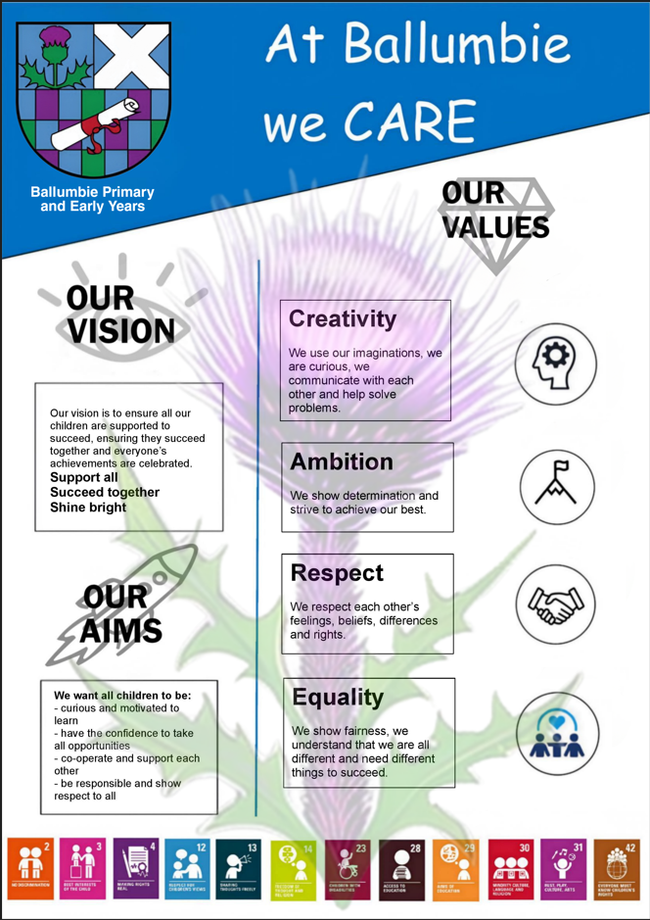

School Priorities 2026-2027

SIP Priority 1 Continue to develop approaches to involve all children in leadership and decision making to ensure children's views improve the work of the school.

Specific area for improvement |  |  | Leadership of Change – ensure progressive leadership skills development an participation in positive change
Rationale for Improvement  (based on evidence from key stakeholders) |  |  | Children were unsure as to how ideas supported positive change. We will develop evaluation and feedback to ensure all stakeholders are aware of change based on feedback. (HMI feedback (January 2026))
NIF PRIORITIES  Improvement in skills and sustained, positive school-leaver destinations for all young people  Choose an item.  Choose an item.  Choose an item.  Choose an item. | NIF DRIVERS  School Leadership  School Improvement  Parental Engagement  Choose an item.  Choose an item.  Choose an item. |  |  | EDLM PRIORITY    Participation |  | PEF (where applicable)  Intervention for equity & cost  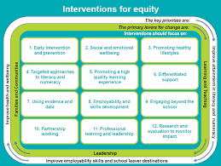  8. Employability and skills development  Choose an item.  Choose an item. |  | HGIOS QI  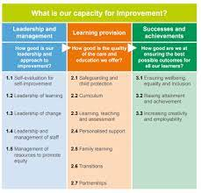  1.3 Leadership of change  Choose an item.
Intended Outcome (impact) |  | Actions required to reach desired outcome |  |  | Measurement & Evidence |  | Who |  | When | Resources
Leadership development is well planned and has a clear focus.  Children can state the leadership skills they are developing as part of their leadership roles.  All stakeholders are aware of key changes and why changes have been made and their role in the change. |  | Review each leadership group – ensure group focus on school improvement.  Develop rationale and key skills focus for each leadership group.  Develop evaluation methods to seek views on change to ensure positive improvements.  Develop a visual display to promote change ideas.  Develop processes to ensure more regular information about learning and progress.  - Consult families and staff  Review how as a school diversity is celebrated. Assembly focus across the year – cultural celebrations |  |  | Children in each group will state leadership skills they are developing.  Parental survey results will show an increase in stakeholders being aware of their role in change. |  | RC  Parent Council  Pupil Leadership groups |  | September 2026  November 2026  December 2026  January 2027  January 2027  September 26 – February 27  September 2026

SIP Priority 2 Ensure children experience a broad and relevant curriculum, develop skills and knowledge across all areas of the curriculum.

Specific area for improvement |  |  | Curriculum – focus on curriculum review, progressive plans in Modern Languages and Technologies
Rationale for Improvement  (based on evidence from key stakeholders) |  |  | Ensure our curriculum meets the needs of all learners, is progressive and relevant. (HMI feedback January 2026)
NIF PRIORITIES  Improvement in skills and sustained, positive school-leaver destinations for all young people  Choose an item.  Choose an item.  Choose an item.  Choose an item. | NIF DRIVERS  Teacher Professionalism  School Leadership  Teacher Professionalism  School Improvement  Choose an item.  Choose an item. |  |  | EDLM PRIORITY  Participation |  | PEF (where applicable)  Intervention for equity & cost  5. Promoting a high quality learning experience  11. Professional learning and leadership  Choose an item. |  | HGIOS QI  2.2 Curriculum  Choose an item.
Intended Outcome (impact) |  | Actions required to reach desired outcome |  |  | Measurement & Evidence |  | Who |  | When | Resources
Ensure children experience a broad and relevant curriculum.  All children develop skills and knowledge across all areas of the curriculum with a focus on Modern Languages and Technologies |  | Work with pedagogy team to develop staff knowledge of national curriculum review.  Review and rewrite our curriculum rationale based on our school context with all stakeholders with support from pedagogy team  Review use of progression pathways of Technologies and Modern Languages to ensure all staff making use of these to plan relevant learning opportunities that are progressive and consistent across all classes.  Review and audit Digital skills journey – plan CLPL for staff team  Develop further opportunities for Expressive Arts across P1 – P7  - RCCT Expressive Arts  - Review arts as a wellbeing tool for groups |  |  | Pathways will be evident and used as part of forward planning.  Staff team can talk about their use of the pathways for children.  Staff will be more knowledgeable about the curriculum review processes and planned changes. |  | RC |  | September 2026 - May 2027 | Pedagogy team

SIP Priority 3 - Continue to improve approaches to learning and teaching to ensure consistently high-quality teaching across the school.

Specific area for improvement |  |  | Learning, Teaching and Assessment
Rationale for Improvement  (based on evidence from key stakeholders) |  |  | A focus on maximised learning time, pace of learning and pupil voice within learning.
NIF PRIORITIES  Improvement in attainment, particularly in literacy and numeracy  Closing the attainment gap between the most and least disadvantaged children and young people  Choose an item.  Choose an item.  Choose an item. | NIF DRIVERS  Teacher Professionalism  Assessment of Children's Progress  School Improvement  Choose an item.  Choose an item.  Choose an item. |  |  | EDLM PRIORITY  Progress |  | PEF (where applicable)  Intervention for equity & cost  5. Promoting a high quality learning experience  11. Professional learning and leadership  Choose an item. |  | HGIOS QI  2.3 Learning, Teaching and Assessment  3.2 Raising attainment and achievement
Intended Outcome (impact) |  | Actions required to reach desired outcome |  |  | Measurement & Evidence |  | Who |  | When | Resources
Learning time is maximised and pace of learning meets the needs of all learners, ensuring engagement and motivation.  Pupil voice is central to ensure all children have a leading role in planning their next steps in learning.  Play is purposeful and pupil led. |  | Work with OSIRIS and pedagogy team to ensure a focus on Learning and Teaching pedagogy in areas of:  Questioning  Pace  Engagement  Develop Succes Criteria to ensure children have good knowledge of learning pathways.  Children set smart goals in writing and numeracy linked to pathway in line with planned learning across the year.  Review of Ballumbie Learning and Teaching standard to ensure key agreed consistencies are added. Add section for Pupil Voice.  Moderation of writing with SIPP schools to continue to support professional judgements. |  |  | Current grading of Good  Aim to have all staff team graded as Good – Very Good |  | PC  AC  KB |  | November 2026 – June 2027 | OSIRIS  Pedagogy team  SIPP

Driving Excellence and Equity
Standards and Quality Report

Ballumbie Primary School

June 2027

Provide a CONCISE description of the school’s context -

In addition to the graphic on page 1 in your SIP (above) include helpful information that sets the scene for your school. What makes it unique?

SIP priority 1 -
Progress including quantitative data to measure progress

Next steps -

SIP priority 2 -
Progress including quantitative data to measure progress

Next steps -

SIP priority 3 -
Progress including quantitative data to measure progress

Next steps -

Improvement in Literacy attainment (include data over time for P1,4, and P7 and comment specifically on how you are closing the poverty related attainment gap 200 words max)

Be sure to capture where current p4s were in P1 and where current P7s were in P4 and P1
Share any good news stories here re attainment in literacy in specific year groups following targeted interventions
Include any improvements related to the work in SIG/EDLM

Literacy | 19/20 (current P7) | 21/22 | 22/23 | 23/24 | 24/25 | 25/26
P1
P4
P7

Literacy | 21/22 | 22/23 | 23/24 | 24/25 | 25/26
Reading
P1
P4
P7
Writing
P1
P4
P7
L & T
P1
P4
P7

Attainment senior phase –
1 or more awards at SCQF level 4 or better (ASN)
1 or more awards at SCQF level 5 or better (SIMD)
1 or more awards at SCQF level 6 or better (SIMD)

Improvement in Numeracy attainment (include data over time for P1,4, and P7 and comment specifically on how you are closing the poverty related attainment gap 200 words max)

Be sure to capture where current p4s were in P1 and where current P7s were in P4 and P1
Share any good news stories here re attainment in literacy in specific year groups following targeted interventions
Include any improvements related to the work in SIG/EDLM

Numeracy | 19/20 (current P7) | 21/22 | 22/23 | 23/24 | 24/25 | 25/26
P1
P4
P7

Numeracy | 21/22 | 22/23 | 23/24 | 24/25 | 25/26
NMM
P1
P4
P7
SPM
P1
P4
P7
Info Handling
P1
P4
P7

Attainment senior phase –
1 or more awards at SCQF level 4 or better (ASN)
1 or more awards at SCQF level 5 or better (SIMD)
1 or more awards at SCQF level 6 or better (SIMD)

Improvement in HWB and positive impact of opportunities for wider achievement (200 words max)

Ensure evaluative writing here and not a list of what is being done but how it impacts positively on pupils. Include quantitative and qualitative data to support your evaluations
Include any improvements related to the work in SIG/EDLM

Improvement in employability skills and positive leaver destinations (secondary schools only) - (200 words max)

Ensure evaluative writing here and not a list of what is being done but how it impacts positively on pupils. Include quantitative and qualitative data to support your evaluations
Include any improvements related to the work in SIG/EDLM
How are you tracking skills across the curriculum? What difference is this making? How do you know?
Include annual participation measure (SDS)

Evaluative comments on attendance and exclusion data (200 words max)

Include how you are making progress towards your school stretch targets.
Include any improvements related to the work in SIG/EDLM
Have exclusion/attendance rates gone up/down? Why? Is there a plan in place to support pupils? Are there successful alternative to exclusion that can be written about here? Click here for Local Authority data for your information.

Evaluation of and the impact of PEF, interventions to tackle inequity and COSD (200 words max)
Ensure evaluative writing here and not a list of what is being done but how it impacts positively on pupils, especially those most affected by inequality. Include quantitative and qualitative data to support your evaluations

Any additional information – Schools may also wish to add further credibility to their reports through independent validation, endorsement or confidence statements, for example based on:
- an inspection from HMI;
- an independent validated self-evaluation; and/or
- Planet Youth data
- specific endorsements/confidence statements from pupil councils, parent councils or local community groups such as employer or partner groups

Attainment senior phase all other subjects –
1 or more awards at SCQF level 4 or better
1 or more awards at SCQF level 5 or better
1 or more awards at SCQF level 6 or better

HGIOS? Quality Indicators | School Grade | HMI grade (in the last 4 years) | Nursery grade | Nursery HMI grade (in last 4 years) | Most recent care inspectorate grade
QI 1.3: Leadership of change

QI 2.3: Learning, teaching, and assessment

QI 3.1: Ensuring wellbeing, equity, and inclusion

QI 3.2: Raising attainment and achievement

QI 3.2: Securing progress (nursery)
Additional QI of school/nursery’s choice e.g. 2.7 partnerships

School Improvement Priorities for next academic year 2026/27

Presence | Priority 1 -  Priority 2 -
Progress | Priority 1 -  Priority 2 -
Participation | Priority 1 -  Priority 2 -

Click here to link to next year’s SIP and SQR ( you need to create a hyperlink to your next plan)

